**Guide to create 3D model in Luma AI**

**Steps:**

1. **Go to** [**https://lumalabs.ai/**](https://lumalabs.ai/)
2. 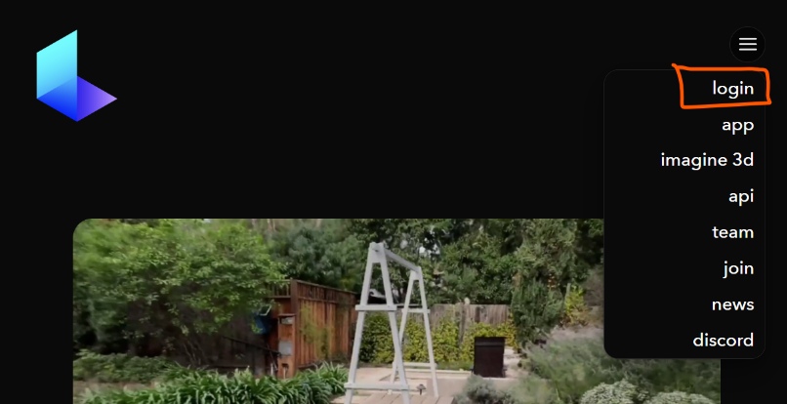**Create an account using your apple id or google id.**
3. **Once in, click on create new button**



1. 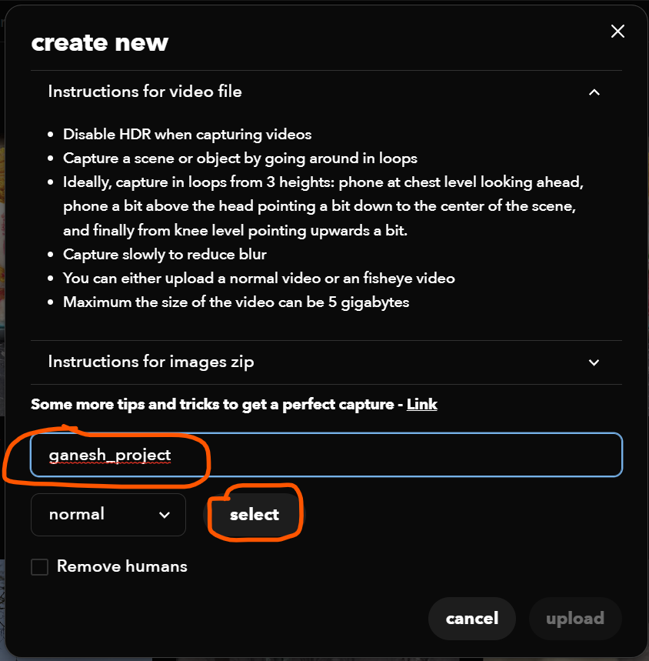**Read the instructions. Give a name to your project and then click on select**
2. **Upload the zip containing your images and click on upload**

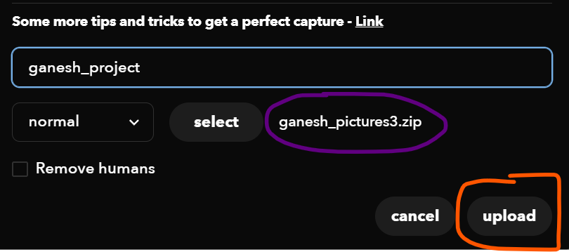

1. 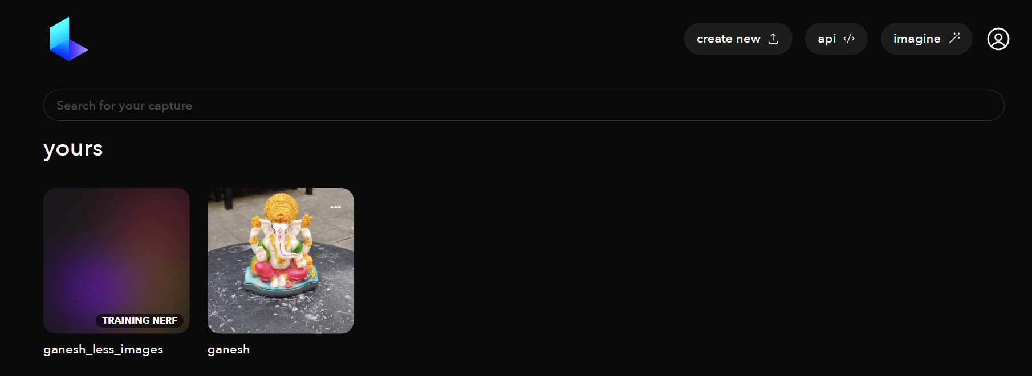**And that’s all. Refresh in few seconds and you’ll see your NeRF creation is in progress**
2. **Which then switches to:**

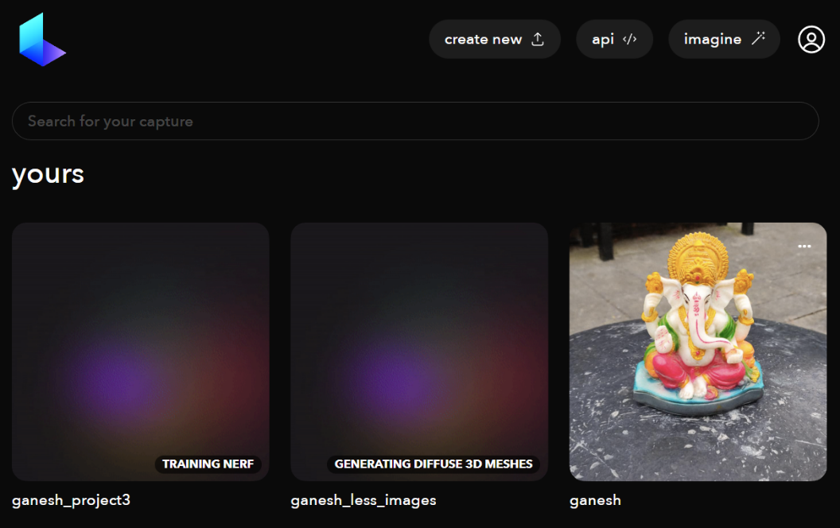

1. 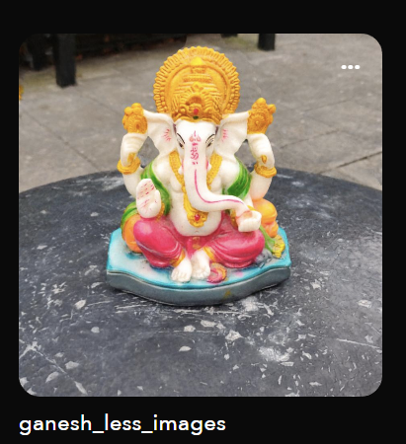**And then you have finally have model ready:**
2. 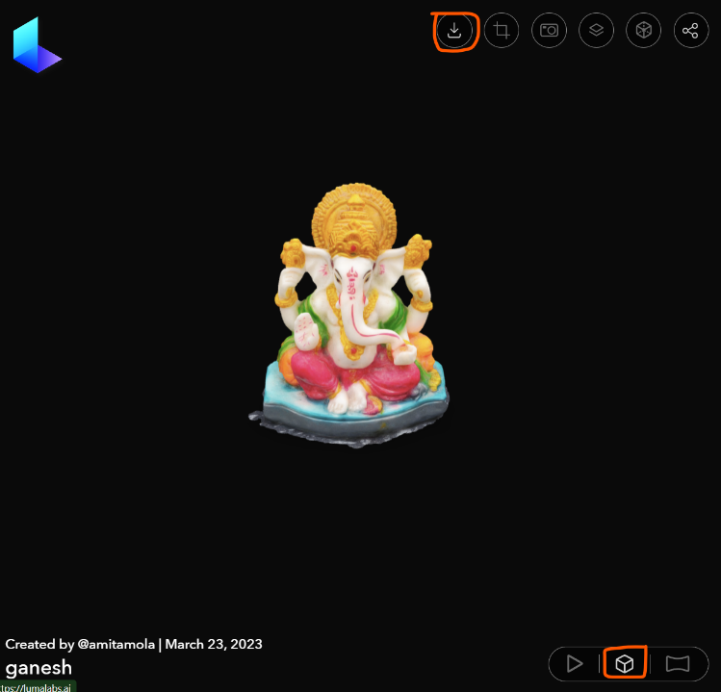**Click on the model and in the bottom click on the 3D object viewer button(2nd one) and then click on download at the top**
3. **It gives you options. You can choose any. Usually preferred to use OBJ format.**

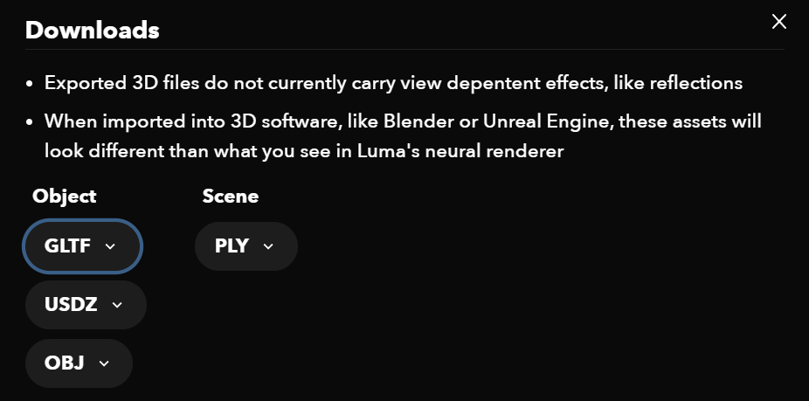

**That’s all folks!**